**USER MANUAL**

Centipede: STAR WARS EDITION

CREATED BY:

Xiang Gao, Justin Lui, and Mackensi Holt

INTRODUCTION:

In a galaxy far far away… like really really far away…

We follow our main protagonist Captain Xiang Gao while he adventures through the galaxy with his faithful droid UH-137, dodging bounty hunters and Imperial starships. All of a sudden, Captain Xiang finds himself trapped in an asteroid field with his nemesis on his tail! A line of Tie Fighters approach his X-Wing head on – weaving though the asteroid field with precision. Help Captain Xiang clear the asteroid field and fight off Tie Fighters, Imperial Star Destroyers, and bounty hunters!

HOW TO PLAY:

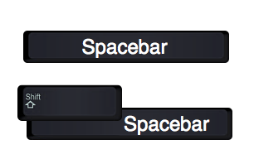

Click SPACEBAR to shoot lasers.

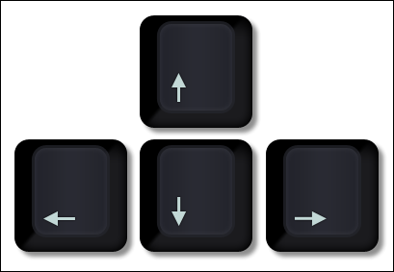

Use ARROW KEYS to move the X-Wing

SCORING:

100 pts for each segment of the Tie Fighter line destroyed.

20 pts for each shot at an asteroid.

20 pts for each Boba Fett head destroyed.

100 pts for each Star destroyer destroyed.

For each 10,000 pts, you will gain 1 additional life.

HACKS:

Do you want more challenge, or to make the game easier?? Press [SPACE] after you one of the following codes:

1. Type [SPACE] to enter Normal Mode.
2. Type [UP][UP][DOWN][DOWN][LEFT][LEFT][RIGHT][RIGHT][A][B][A][B] to enter 30 Life Mode.
3. Type [P][F][I][A] to enter Power Mode.
4. Type [M][F][A][B][W][Y] to enter Fast Shooting Mode.
5. Type [N][M][A] to enter Nightmare mode.